IFB299 Project Design and Development

Group 114 – Smart City Project

**Justification of Smart City Architecture Pattern.**

The Smart City project will require the use of database & Django functionality to accomplish set user goals. The final product will be able to interface with a server-stored database, adding and modifying data entries at the whim of the administrator user.

The product will also need to be able to perform complicated logic processing independent of database interface, while still having access to server-side security.

According to D. Tony Liu and William Xu’s paper, *A review of web-based product data management systems*, this kind of functionality can only be accommodated by an architecture with three or more tiered layers. Xu and Liu explain how ‘logic processing’ is an individual component which allows user requests to be personalised [2001, 2.2 Evolution of PDM methodology. Paras. 17-19].

The Smart City project will benefit greatly from a faster, more personalised experience, given the large audience scope implied by the assignment specification.

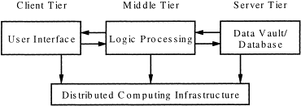

[adapted from *Computers in Industry* by Liu, D. T. & Xu, X. W, figure 3]

Reference:

Liu, D. T., & Xu, X. W. (2001). A review of web-based product data management systems. *Computers in industry*, *44*(3), 251-262.